Technical Report

Project

* Automate the process of calculating relative grading for a particular subject based on mean and standard deviation of marks obtained for all students.

· System should accept marks of all students for a particular subject.

· Relative grading depends on what is the highest mark for that subject with in the class.

· Please refer internet to know the complete process and formula to calculate relative grading.

Project Description

* Improvisation is done on the project for accepting any number of subjects for assigning relative grading by adding a do-while loop

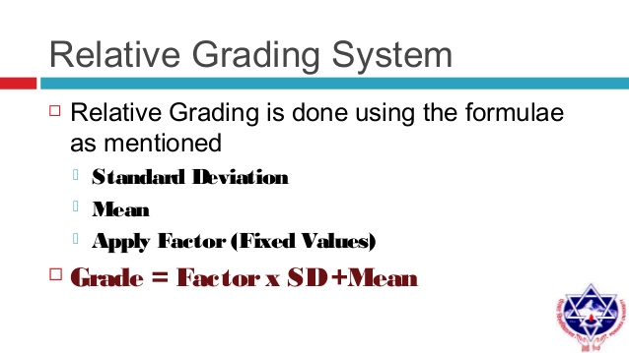

* The solution for relative grading is brought taking grading system of VIT UNIVERSITY as reference

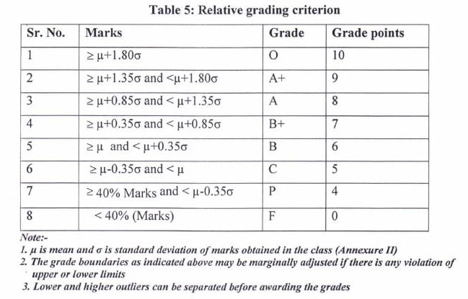

Features of Project

The requirements of the project

* List of marks of students of one or more subjects
* The total marks for which the test is conducted
* The program displays the mean, variance of marks obtained by students in a subject
* The list of students who obtain similar grade is also displayed
* Ultimately we have automated the allotment of relative grading for each student based on the mean and variance

Test Scenarios

* We have given the marks grater than total marks for which the exam is conducted
* 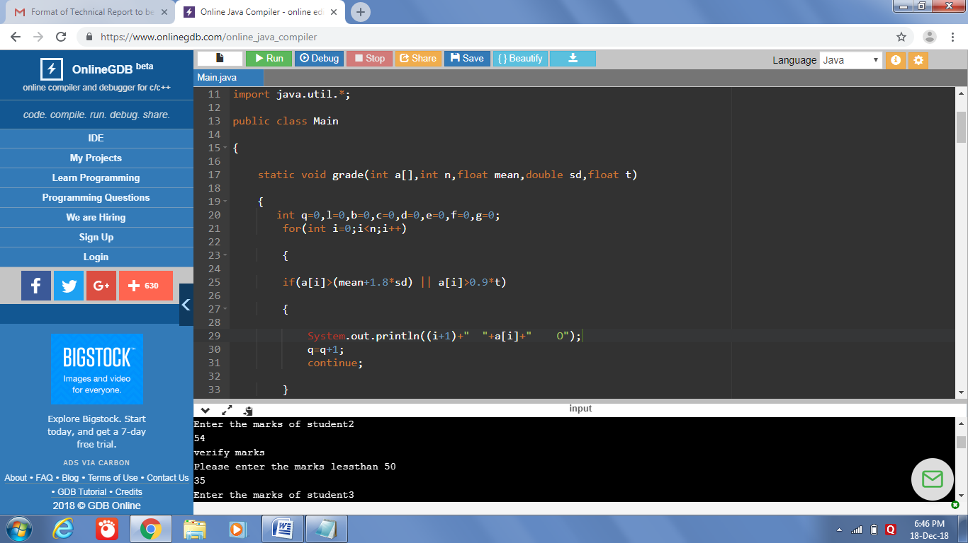
* We have given a negative number
* 
* 

Contribution

Pavan Kumar(17331A05E0) has done coding

Shanmukh Nagrndra(17331A05D5) has collected the related info and formulae

Krishna Kantha(18335A0517) is responcible for test scenarios

Sasi Kumar(17331A05E6) was been explained the entire code

Ramakanth Soni(17331A05D6) engaged in IIT MUMBAI Fest

Sai Kumar Pydi(17331A05D4) engaged in IIT MUMBAI Fest

Learning

The Relative grading is a pure competitive level of grading. It is purely based upon the entire performance of all the students ,which relies on the toughness level of the examination. Students are not graded on the standard percentages but by the mean and variance of the marks of total students.

Regarding code

* Formulae Used:

MEAN=(Sum of marks of all students / Total no of Students)

VARIANCE= [(givem marks-mean)^2 ] / Total no of Students)

STANDARD DEVIATION = sqrt(variance)

* Declaring a data type inside a do-while loop doesn’t reflect in the while statement

Code

import java.io.*;

import java.util.*;

public class project

{

static void grade(int a[],int n,float mean,double sd,float t)

{

int q=0,l=0,b=0,c=0,d=0,e=0,f=0,g=0;

for(int i=0;i<n;i++)

{

if(a[i]>(mean+1.8*sd) || a[i]>0.9*t)

{

System.out.println((i+1)+" "+a[i]+" O");

q=q+1;

continue;

}

if((a[i]>(mean+1.35*sd) && a[i]<=(mean+1.8*sd)) || a[i]>0.8*t)

{

System.out.println((i+1)+" "+a[i]+" A+");

l=l+1;

continue; }

if(a[i]>(mean+0.85*sd) && a[i]<=(mean+1.35*sd))

{

System.out.println((i+1)+" "+a[i]+" A");

b=b+1;

continue;

}

if(a[i]>(mean+0.35*sd) && a[i]<=(mean+0.85*sd))

{

System.out.println((i+1)+" "+a[i]+" B+");

c=c+1;

continue;

}

if(a[i]>(mean) && a[i]<=(mean+0.35*sd))

{

System.out.println((i+1)+" "+a[i]+" B");

d=d+1;

continue;

}

if(a[i]>(mean-0.35*sd) && a[i]<=(mean))

{

System.out.println((i+1)+" "+a[i]+" C");

e=e+1;

continue;

}

if(a[i]<=(mean-0.35*sd) && a[i]>=0.4*t)

{

System.out.println((i+1)+" "+a[i]+" P");

f=f+1;

continue;

}

if(a[i]<0.4*t)

{

System.out.println((i+1)+" "+a[i]+" F");

g=g+1;

continue;

}

}

System.out.println("number of students who got O grade are "+q);

System.out.println("number of students who got A+ grade are "+l);

System.out.println("number of students who got A grade are "+b);

System.out.println("number of students who got B+ grade are "+c);

System.out.println("number of students who got B grade are "+d);

System.out.println("number of students who got C grade are "+e);

System.out.println("number of students who got P grade are "+f);

System.out.println("number of students who got F grade are "+g);

}

public static void main(String args[])

{

System.out.println("This is a code for relative grading.");

System.out.println("The operations that can be performed are");

System.out.println("***mean calculation***");

System.out.println("***standard deviation calculation***");

System.out.println("***Grading based on marks***");

System.out.println("***Number of Grades achived by number of students***");

int y;

do

{

int x;

float total=0,to=0;

float mean,v=0;

float m;

double sd;

System.out.println("enter the no student");

Scanner s=new Scanner(System.in);

int n=s.nextInt();

System.out.println("enter the marks for which test is conducted:");

int t=s.nextInt(); int a[]=new int[n];

for(int i=0;i<n;i++)

{

System.out.println("Enter the marks of student"+(i+1));

x=s.nextInt();

if(x>t || x<0)

{

System.out.println("verify marks");

System.out.println("Please enter the marks lessthan "+t);

a[i]=s.nextInt();

}

if(x<=t)

{

a[i]=x;

}

}

for(int i=0;i<n;i++)

{

total=total+a[i];

}

mean=total/n;

for(int i=0;i<n;i++)

{

v=(a[i]-mean)*(a[i]-mean);

to=to+v;

}

m=to/n;

sd=Math.sqrt(m);

System.out.println("Mean marks are "+mean);

System.out.println("Standard deviation is "+sd);

System.out.println("Variance is "+v);

System.out.println("S.NO MARKS GRADE");

grade(a,n,mean,sd,t);System.out.println("do you want to enter some other subject marks:");

System.out.println("choose 1 for yes or 0 for no:");

Scanner p=new Scanner(System.in);

y=p.nextInt();

} while(y==1);

}

}

Output:





    
    
    
    
    
    
    
    
    
    
    
    
    